TECHNICAL PROPOSAL
Development of NUSA Website

Project | NUSA Website Development
Proposal Type | Technical Proposal
Prepared On | 06 April 2026

1. Executive Summary
Naria Unnayan Samity (NUSA) intends to replace its current information-centric web presence with a modern, accessible, bilingual, and impact-oriented digital platform. Based on the ToR, the target solution must serve donors, partners, community members, and internal administrators through a secure and easy-to-manage website that highlights transparency, programs, publications, impact stories, careers, and engagement pathways.
This solution is built from-scratch implementation using a React-based public website with a Laravel-powered backend CMS and admin layer. The approach is designed to satisfy the ToR requirements for mobile-first user experience, English and Bangla content support, WCAG 2.1 Level AA accessibility, low-bandwidth access, IATI-aligned transparency publishing, security hardening, SEO readiness, and structured training and handover.
2. Project Understanding and Objectives
The uploaded ToR positions this initiative as a strategic digital transformation effort rather than a simple website refresh. The new platform is expected to improve donor transparency, beneficiary accessibility, organizational credibility, and digital outreach while remaining lightweight enough for users on constrained networks and mobile devices.
- Build a new impact-oriented corporate website from scratch.
- Present NUSA programs, reports, policies, publications, events, and stories in a structured way.
- Support bilingual content management for English and Bangla.
- Enable secure donation and participation journeys for donors, volunteers, and applicants.
- Provide a maintainable admin environment with security controls, backups, analytics, and handover documentation.
3. Confirmed Scope Alignment
The proposed scope below is directly aligned to the ToR and excludes custom modules that are not expressly needed for the first release.
ToR Area | Proposed Coverage | Included
Public website sections | Home, About, Programs and Projects, Publications/Reports/Impact Stories, News and Events, Gallery, Partners and Donors, Get Involved, Contact | Yes
Transparency hub | Annual reports, audit statements, policy documents, and governance-related content structure | Yes
Interactive impact map | Map-based intervention area presentation using a practical website-friendly implementation | Yes
Human interest stories | Story pages with image/video support and reusable content templates | Yes
E-recruitment | Career listings, volunteer opportunities, structured application form, and admin-side submission review | Yes
Donation journey | Secure donation page and CTA tracking with integration-ready approach based on selected payment provider | Yes
Partner portal | Controlled access area for approved partner or donor resources, kept lightweight for first release | Yes
Optional innovation items | AI chatbot, PWA, green hosting optimization package, real-time public dashboard | Deferred

4. Proposed Technical Approach
4.1 Solution Architecture
To satisfy the requirement for a scalable and maintainable solution while keeping the implementation practical, we propose headless-style architecture. The public website will be built with a React-based frontend for performance and SEO-friendly rendering, while Laravel will provide the backend CMS, API layer, admin authentication, media handling, and content workflows. This approach is compatible with the ToR direction for either headless CMS or highly optimized website architecture and is well-suited for a new build from scratch.
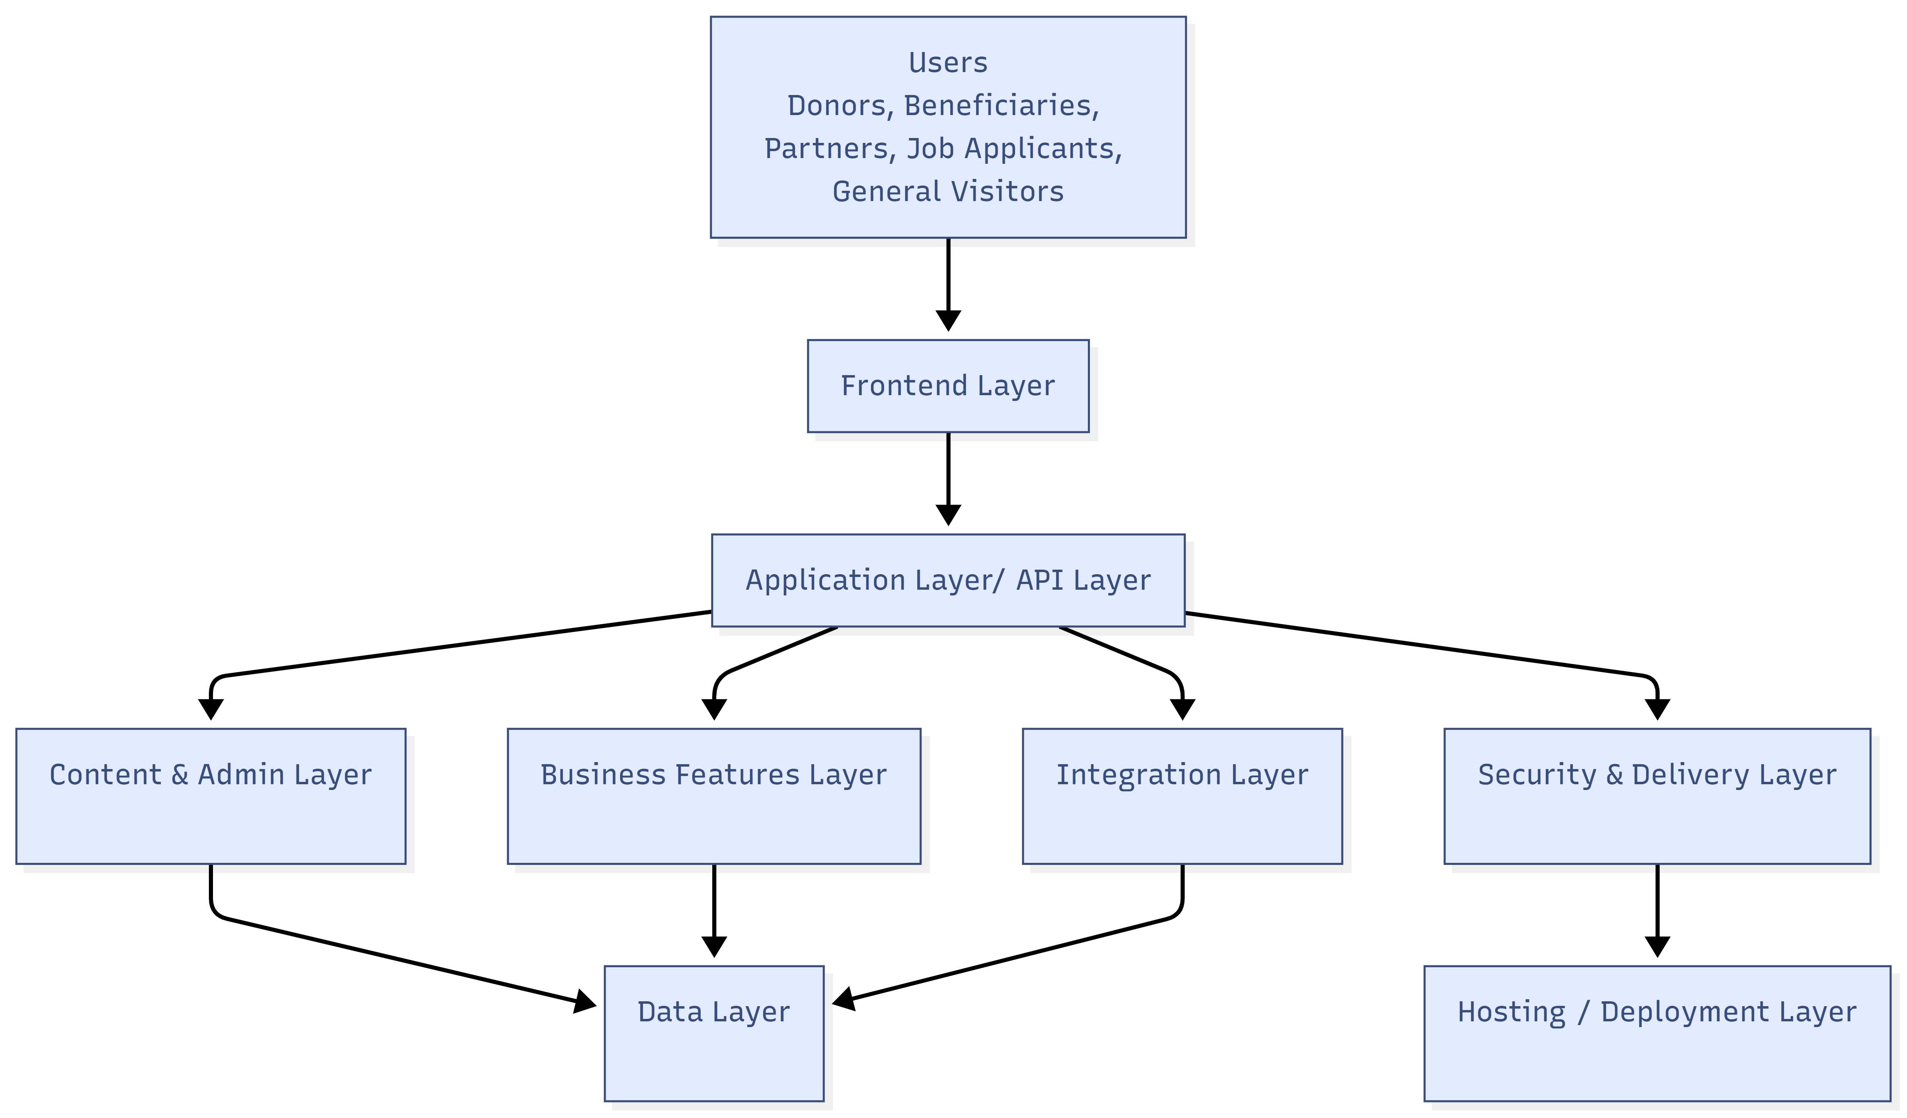
Figure 1. Proposed high-level solution architecture for the NUSA website platform
4.2 UX/UI and Content Experience
- Discovery-led information architecture focused on donors, partners, beneficiaries, and applicants.
- Mobile-first interface design with clear visual hierarchy and simplified navigation.
- English and Bangla content support with Unicode-safe data structure and page templates.
- Accessible interface patterns for keyboard use, readable contrast, alt text, focus states, and semantic layout.
- Lite-mode and optimized asset delivery approach for low-bandwidth browsing.
4.3 Functional Implementation Approach
- Component-based frontend development so that major sections remain consistent and easy to maintain.
- Reusable backend content modules for pages, reports, policies, stories, events, galleries, careers, and partner resources.
- Form processing for contact, volunteer/career applications, and donation intent flows.
- Map content model for intervention areas without forcing a heavy custom GIS platform in the first release.
- SEO and analytics configuration for page metadata, schema markup, indexing readiness, and CTA event tracking.
4.4 Security, Privacy, and Operations
- Role-based admin access with MFA for privileged users.
- Secure coding, server hardening, and protection against common web vulnerabilities.
- Daily off-site backup routine for database and uploaded documents/media.
- Controlled plugin and package usage with update governance.
- Logging, monitoring, and launch-readiness checklist before production release.
5. Proposed Technical Stack
The technology stack below is selected to support SEO, accessibility, bilingual content delivery, maintainability, and secure administration, while staying practical for a cost-conscious delivery. The frontend and backend choices are kept consistent with the requested React and Laravel direction.
Layer | Recommended Stack | Purpose
Frontend | Next.js (React) | Public website rendering, SEO-friendly pages, multilingual UI, responsive delivery
Backend | Laravel | Admin panel, CMS, APIs, form handling, authentication, business rules
Database | MySQL | Structured content, forms, users, reports, and system data
Storage | Object/File Storage | Documents, publications, images, reports, and backups
Web Server | Nginx | Application serving, reverse proxy, compression, caching rules
Security | MFA + WAF/CDN | Admin protection, traffic filtering, caching, and delivery acceleration
Analytics | Google Analytics 4 | Event tracking for donate and get involved journeys
SEO | Schema markup + sitemap | Indexability, discoverability, and structured metadata
Maps | Web map integration | Intervention area display for the impact map section
Notifications | SMTP / transactional email | Career application alerts, form notifications, and admin messages
6. Development Methodology
We recommend a phased but tightly controlled implementation model that mirrors the ToR milestone structure. Each phase ends with review and approval before the next stage proceeds.
- Discovery and planning: stakeholder sessions, content audit, information architecture, project plan, and approval checkpoints.
- UX/UI design: wireframes, desktop/mobile mockups, accessibility review, and design sign-off.
- Development: frontend and backend implementation in staging, followed by iterative internal testing.
- QA: functional testing, cross-device testing, accessibility validation, security review, and user acceptance validation.
- Launch and training: production deployment, SEO indexing setup, admin training sessions, user manual handover, and support transition.
7. Deliverables
The following deliverables are planned for this engagement.
Phase | Deliverables | Output
I. Discovery | Kick-off meeting, stakeholder notes, scope validation, information architecture, and inception summary | Approved inception pack
II. Design | Wireframes, UI design system, responsive page mockups, accessibility considerations, and design revision cycle | Approved UI/UX set
III. Development | React frontend, Laravel backend CMS/admin, bilingual structure, content modules, forms, map, and staging deployment | Functional beta on staging
IV. QA | Test execution, issue fixing, accessibility checks, security hardening, and support | QA-ready release candidate
V. Launch | Production deployment, DNS cutover support, analytics setup, SEO readiness, and stabilization | Live production release
VI. Training | At least 2 training sessions, admin manual, handover checklist, and support transition | Training completion and handover pack
8. Testing and Quality Assurance
Quality assurance will be built into the implementation rather than treated as a final-stage activity only. This is important for accessibility, performance, security, and content integrity.
QA Area | Coverage | Expected Outcome
Functional testing | Navigation, forms, CMS actions, bilingual rendering, documents, careers, portal access | All agreed modules behave correctly
Responsive testing | Mobile, tablet, desktop, common browsers, and content layout checks | Consistent experience across devices
Accessibility testing | Keyboard navigation, semantic structure, alt text, contrast, readable focus states | WCAG 2.1 AA-aligned delivery target
Performance testing | Page speed, optimized media, lazy loading, caching, and lite-mode validation | Fast loading and stable UX
Security testing | Admin authentication, MFA, permissions, input validation, backup checks | Reduced exposure to common attack vectors


Fig: QA Test Process
9. Proposed Implementation Timeline
We propose a 10-weeks delivery window from kick-off to final training and handover.
10. Training, Handover, and Support
- Two training sessions covering content publishing, document management, careers handling, and day-to-day website operations.
- Delivery of a concise user manual for content editors and administrators.
- Structured handover of source code, deployment package, credentials handoff checklist, and backup process overview.
- Twelve months of technical support as stated in the ToR, including critical bug turnaround expectations and routine maintenance guidance.
11. Assumptions and Controlled Exclusions
To maintain delivery control and avoid unnecessary cost expansion, the proposal assumes the following.
- Final content, translations, policy documents, reports, and media assets will be provided or approved by NUSA during the project.
- Any third-party payment provider, map data source, hosting subscription, CDN plan, email service, or analytics account requiring direct procurement will be selected or approved by NUSA.
- The partner portal is scoped as a lightweight protected-access area, not a large collaboration platform.
- The impact map is scoped as a practical website presentation module and not as a full custom GIS application.
- AI chatbot, PWA packaging, green hosting advisory, and real-time public dashboard are not part of the core build unless separately prioritized during discovery.

